WEEK 7: MONITORING (Azure Monitor)
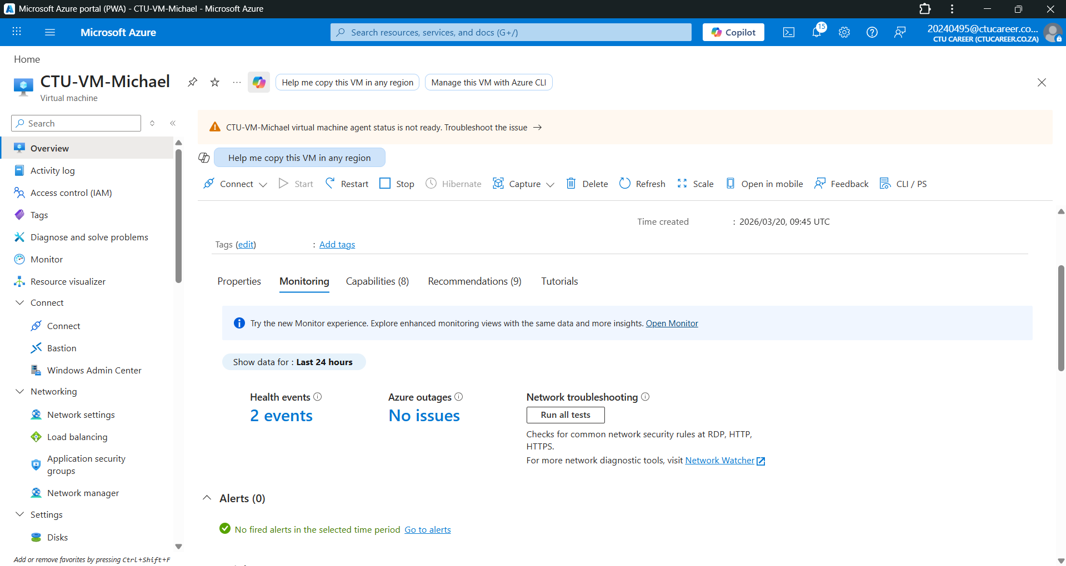

I enabled Azure VM Insights on my virtual machine to collect performance data such as CPU usage, disk activity, and network performance. The data is sent to a Log Analytics Workspace where it is stored and processed. This allows Azure Monitor to analyse performance trends and generate visual metrics in real time.
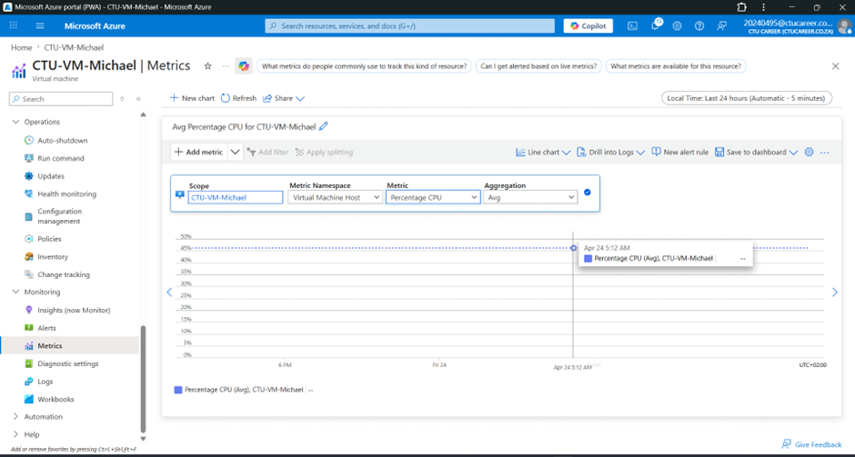
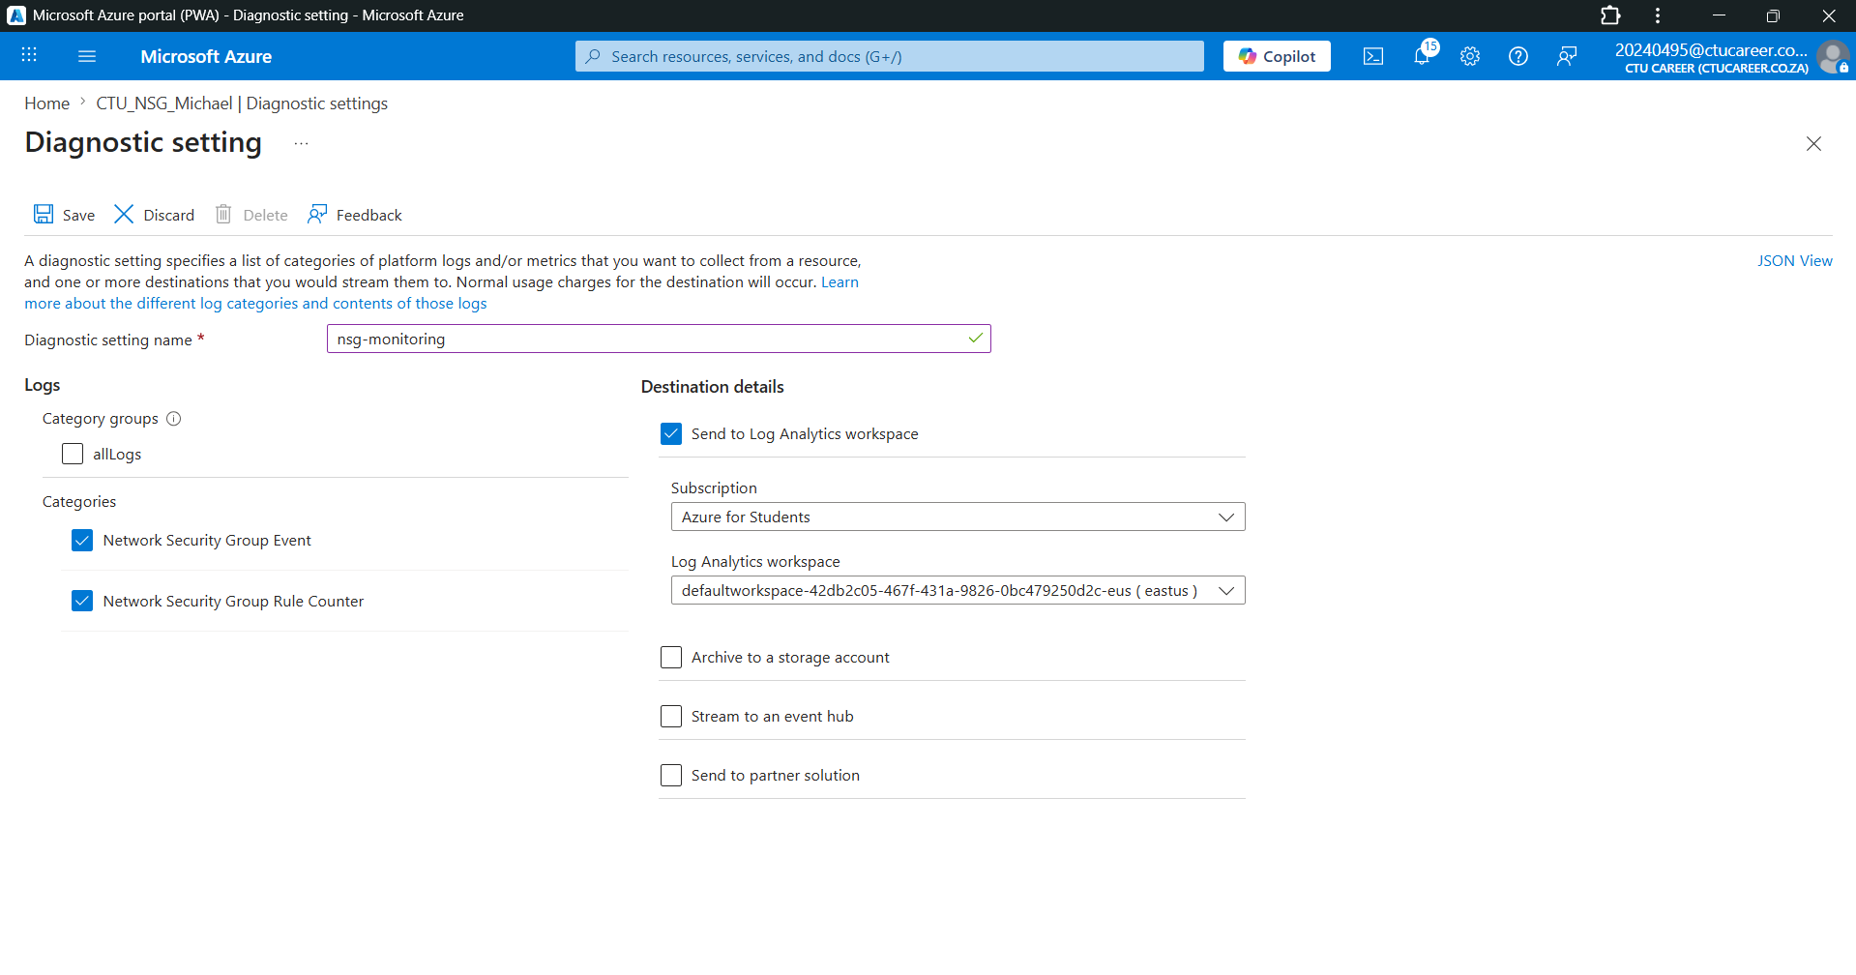

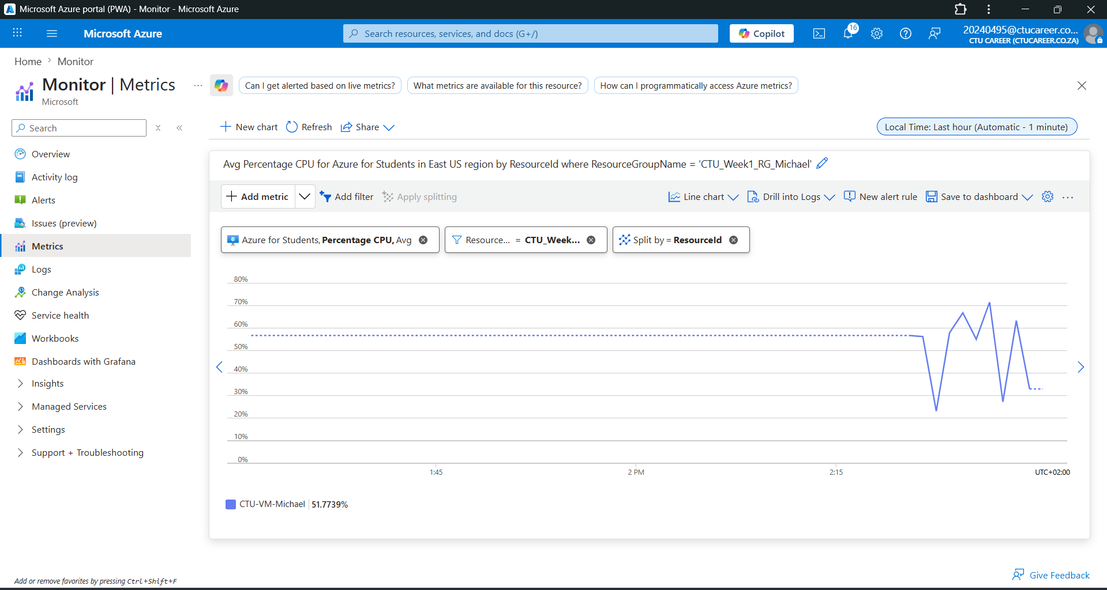
The CPU metric shows the percentage of processing power being used by the virtual machine over time. The values appear normal for a lab environment, with small spikes caused by background system activity or test workload.
The network metric shows data being sent and received by the VM in bytes. The unit is usually bytes per second or total bytes. Traffic increases when the VM downloads updates or communicates with external services.

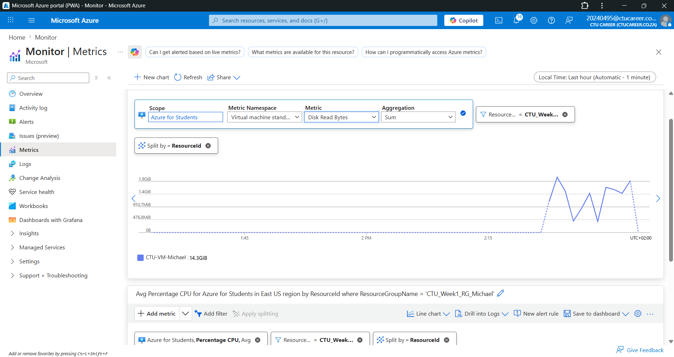

Disk metrics show how much data is being read from and written to the virtual machine storage. Write activity increases when installing software, updating the system, or saving files.
Resources Monitored
Monitoring was enabled on a virtual machine using VM Insights and on network resources using Diagnostic Settings. The VM collects CPU, memory, disk, and network performance metrics. The NSG collects security logs such as traffic flow and rule hits, while the VNet diagnostic settings capture network-level telemetry.
Data Storage
All monitoring data is stored in a Log Analytics Workspace. The default retention period is typically 30 to 90 days depending on configuration. Historical data beyond this period can be accessed by exporting logs to Azure Storage or increasing retention settings in the workspace.
Metric Observations
CPU usage remained low with occasional spikes due to background processes. Network activity showed small bursts of inbound and outbound traffic. Disk activity increased during system operations. In a production environment, anomalies could be caused by malware, high user load, or misconfigured applications.

1. Why monitoring is important?
Monitoring is important because it allows administrators to track system performance, detect issues early, and ensure services remain available. In cloud environments, monitoring is more dynamic and real-time compared to traditional on-premises systems.
2. Metric vs Log
A metric is numerical performance data like CPU usage. A log is a detailed record of events such as errors or system activities. Metrics are used for performance monitoring, while logs are used for troubleshooting.
3. High CPU at 2am
I would investigate scheduled tasks, background updates, or malware scans. I would also check process-level CPU usage and review logs to identify the cause.
4. Cost optimisation
Monitoring data helps identify underused resources so they can be resized or shut down. It also helps detect over-provisioned VMs, reducing unnecessary costs.

